**Printed Roll Manager Dependencies**

1. **Storage Locations are required and can be maintained using the Storage Location Maintenance application which is on your table maintenance menu. For a brief description of Storage Locations see** [**Defined Codes**](https://docs.google.com/document/d/1x0TdtVWv93G_EOrGfDpOqyF17ZjeZcbKcExGnHjMw3o)**.**
2. **Quality Classifications are required, and while they are provided by Solstice (ACCEPTABLE and OFFQUALITY), the description displayed can be modified to be more meaningful if requested.**
3. **Quality Class Reasons are required when a master roll is given a classification of ‘OFFQUALITY’ and can be maintained using the Quality Class Reasons Maintenance application which is on your table maintenance menu. For a brief description of Quality Class Reasons, see** [**Defined Codes**](https://docs.google.com/document/d/1x0TdtVWv93G_EOrGfDpOqyF17ZjeZcbKcExGnHjMw3o)**.**

## Printed Roll Manager

Printed Roll Manager allows supervisors to create new printed rolls that are not in inventory, possibly because the were created before PlantVista was in place. It can also be used to adjust printed rolls that were created incorrectly. It should be used for exception cases only and be restricted to supervisors. The location, quality classifications and length of the rolls can be adjusted. The **material part number (erp_part)** as exists in AX can also be updated. Printed rolls can consumed as well.

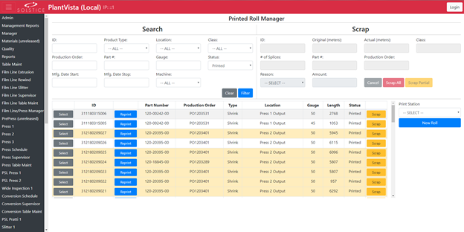

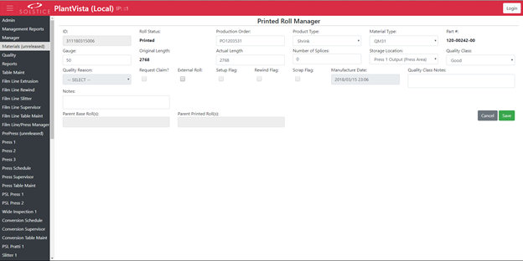

To **filter the list**, choose selection criteria from the Search area and press ‘Filter’. The number of items in the list will be limited to those that match the entered criteria.

To **edit an existing Material** **SKU Unit**, press the ‘Select’ button next to the desired printed roll, make the adjustments and press ‘Save’

.

To **scrap a printed roll**, press the ‘Scrap’ button next to the desired material. The roll information will appear in the ‘Scrap’ section at the top right. The operator can press the ‘Scrap All’ button, or to only scrap a portion of the remaining roll, the operator can adjust the total quantity displayed in ‘amount’ field to be the remaining meters, and press ‘Scrap Partial’ to partially consume the item. Leaving the original amount in the field will cause the entire roll to be consumed.

To **reprint a label for a printed roll**, press the ‘Reprint’ button.

To **create a new roll,** press the ‘New Roll’ button, fill in the information and press ‘Save’.